Assignment –1 Creating sample tables and inserting values.

SALESPEOPLE Snum int(4) Sname varchar(10) City varchar(10) Comm float(3,2

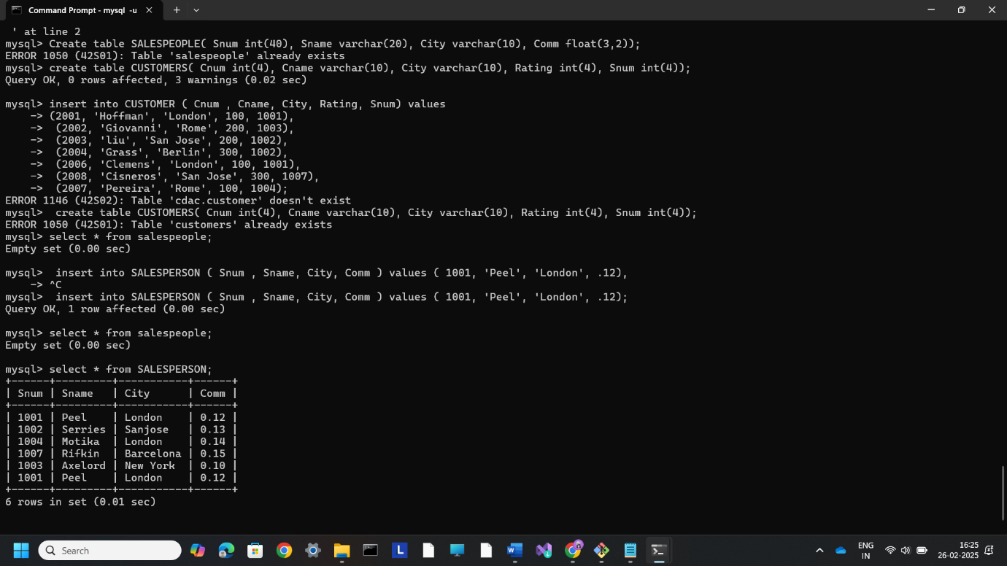

ORDERS Onum int(4) Amt float(7,2) Odate date Cnum int(4) Snum int(4)

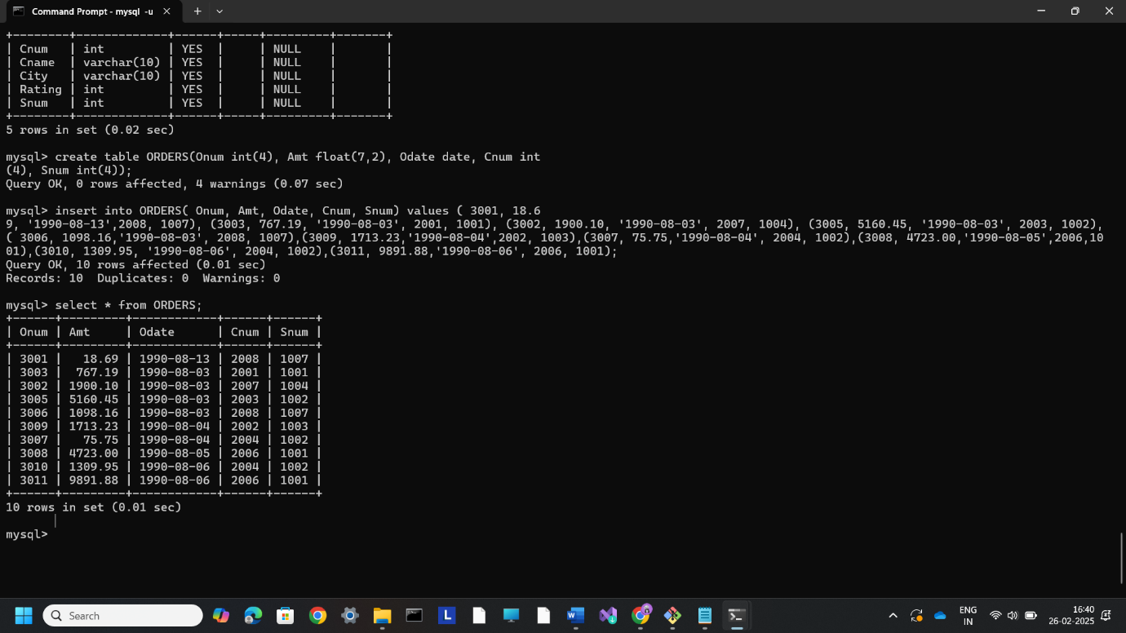

CUSTOMERS Cnum int(4) Cname varchar(10) City varchar(10) Rating int(4) Snum int(4)

